**Practical 1**

LINUX

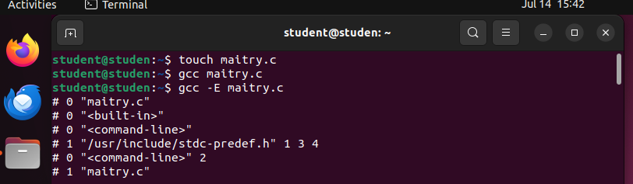

* the first file is formed by the touch tool
* It is named in format Here of “ name.c”

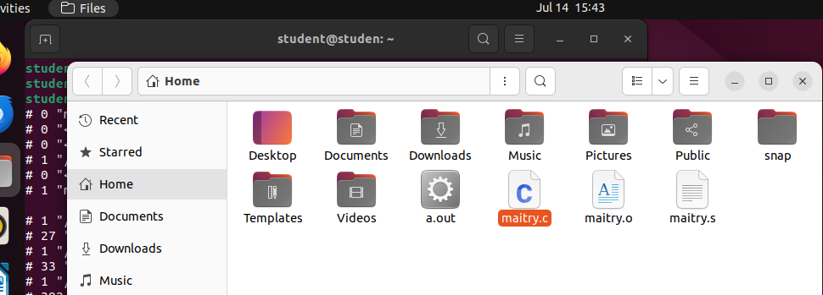

* The other folder is maitry.s
* And the third folder is maitry.o
* This maitry.o will not open. As it has codes which not shown as someone would might copy it.

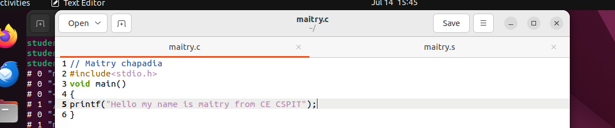

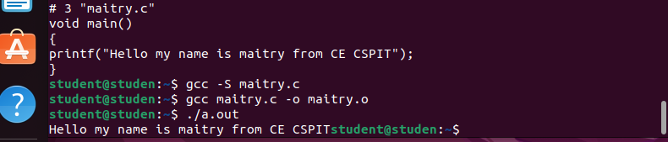

* We got the output by “./a.out” which creates a folder of it.

CODEBLOCK

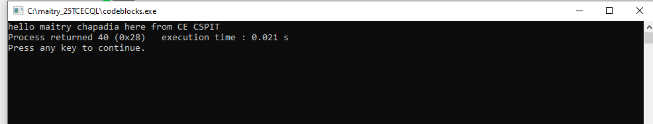

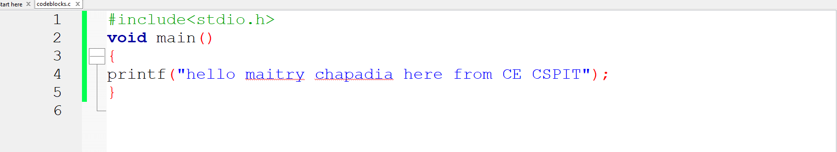

Integer

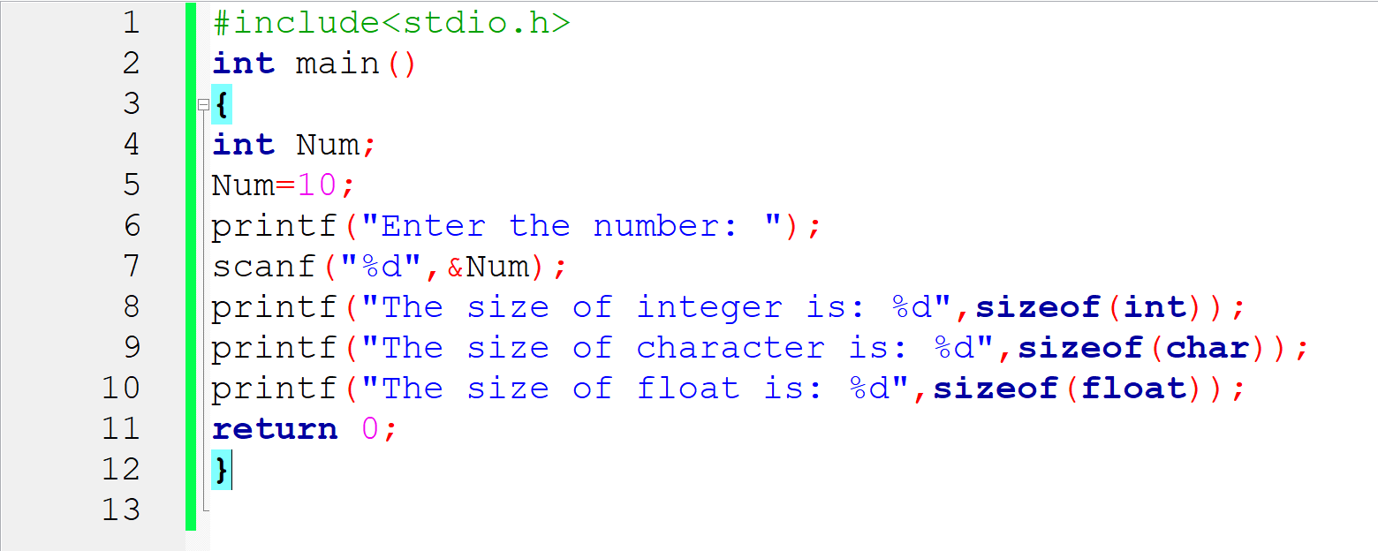

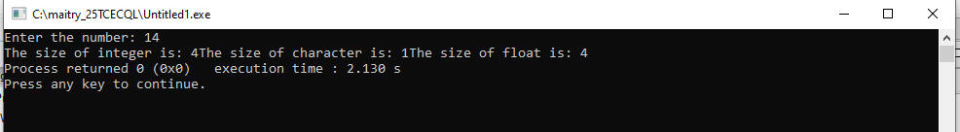

**Practical 2**

Integer Que

To find the area and the perimeter of the park whose length is 70 and breadth is 90 in the codeblock

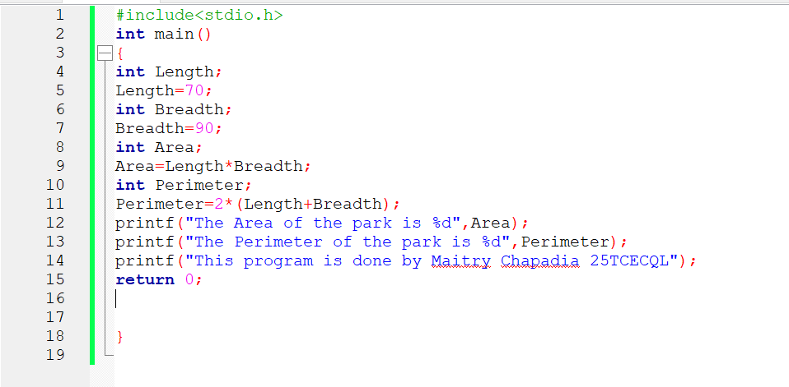

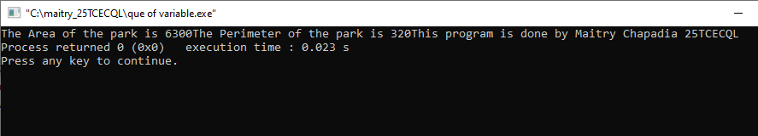

**Practical 3**

Measurements

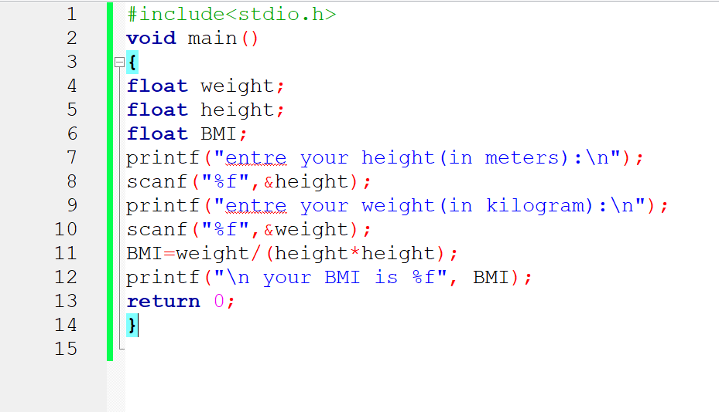

* here the float express the variables.
* Scanf is used for the next line .
* For scanf we use “%f”.
* BMI=weight devided by the square of height.

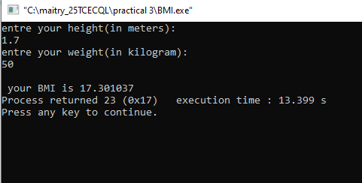

**Practical 5**

Population

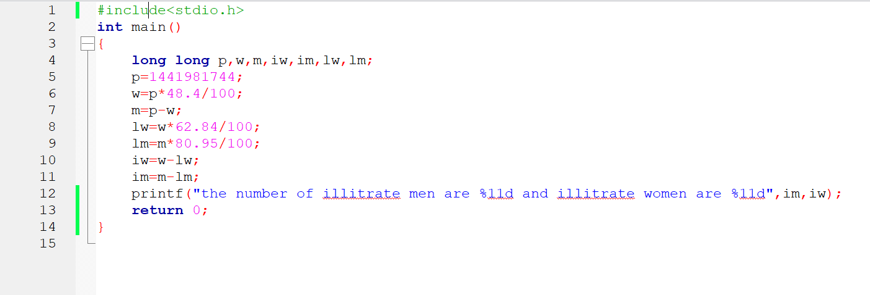

* Here there is the calculation of illiterate men and women from total population of 1,44,19,81,744 people
* Here we have given the percentage of literate men and literate women

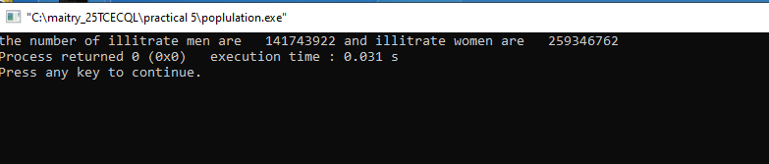

* So we get illiterate men 141743922 and illiterate women 259346762

**Practical 4**

Size and Ranges

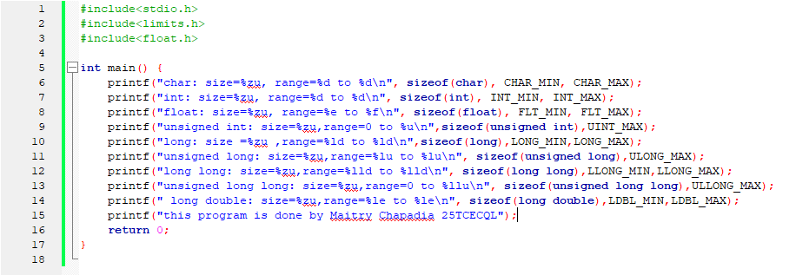

* Here very data type has it’s own size and ranges.

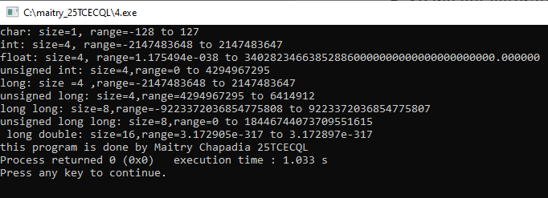

**Practical 6**

Temperature conversation

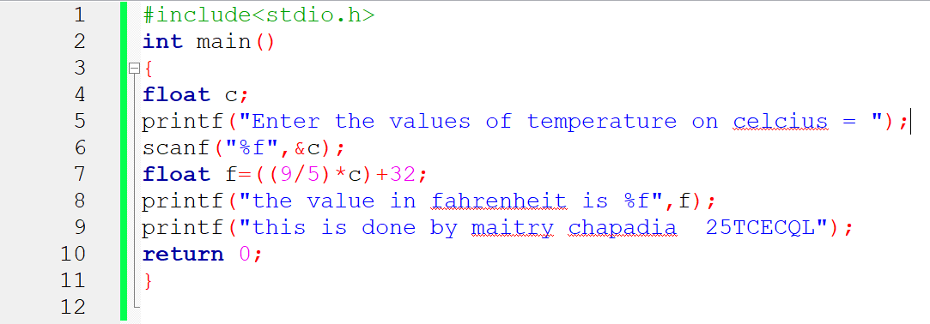

* Here we are doing the conversion of temperature from Celsius to fahrenheit
* With formula ((9/5)*C)+32

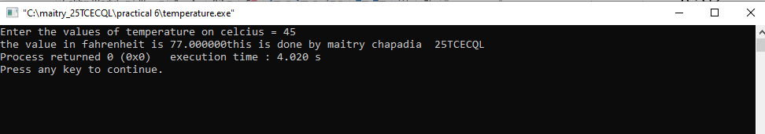

* Here we entre the values of temperature in Celsius and get the answer in Fahrenheit.

**Practical 7**

Tickets collection

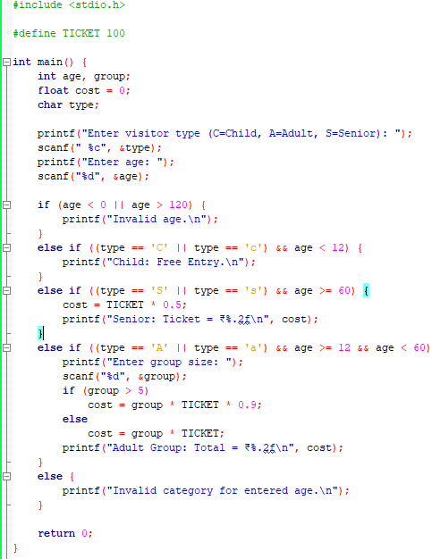

* This program decides if a visitor should get free or discounted entry based on age.
* It uses if, else if, and else statements for decision-making.
* The program includes categories: Child, Adult, Senior Citizen.
* Age is validated to ensure it's within a realistic range (0–120).

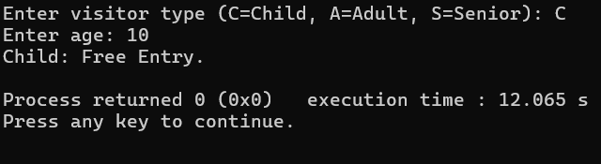

Visitors under 12 are classified as children.

The program correctly gives **free entry** to children below 12.

* Visitors between 12 and 59 are classified as adults.
* If more than 5 adults are entered in a group, a **10% discount** is applied.
* Shows total ticket price calculated using the group size.

Visitors aged 60 or more are classified as senior citizens.

They receive **50% discount** on the ticket fare.

**Practical 8**

Bank account

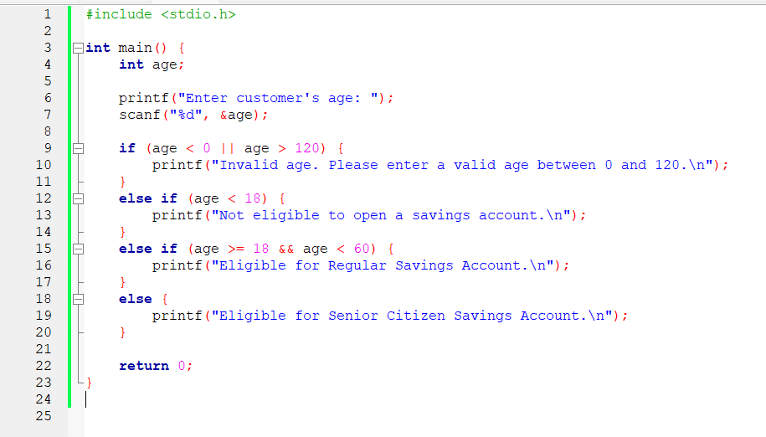

* This program checks if a customer is eligible to open a savings account based on their age.
* It uses if, else if, and else statements to classify customers.
* Age is taken as input, and conditions are applied to determine eligibility type.
* Invalid age input is handled using a condition (age < 0 || age > 120).

When a customer under 18 years old is entered, the program displays "Not eligible to open a savings account."

If the entered age is between 18 and 59, the program shows "Eligible for Regular Savings Account."

When age is 60 or more, the program shows "Eligible for Senior Citizen Savings Account."